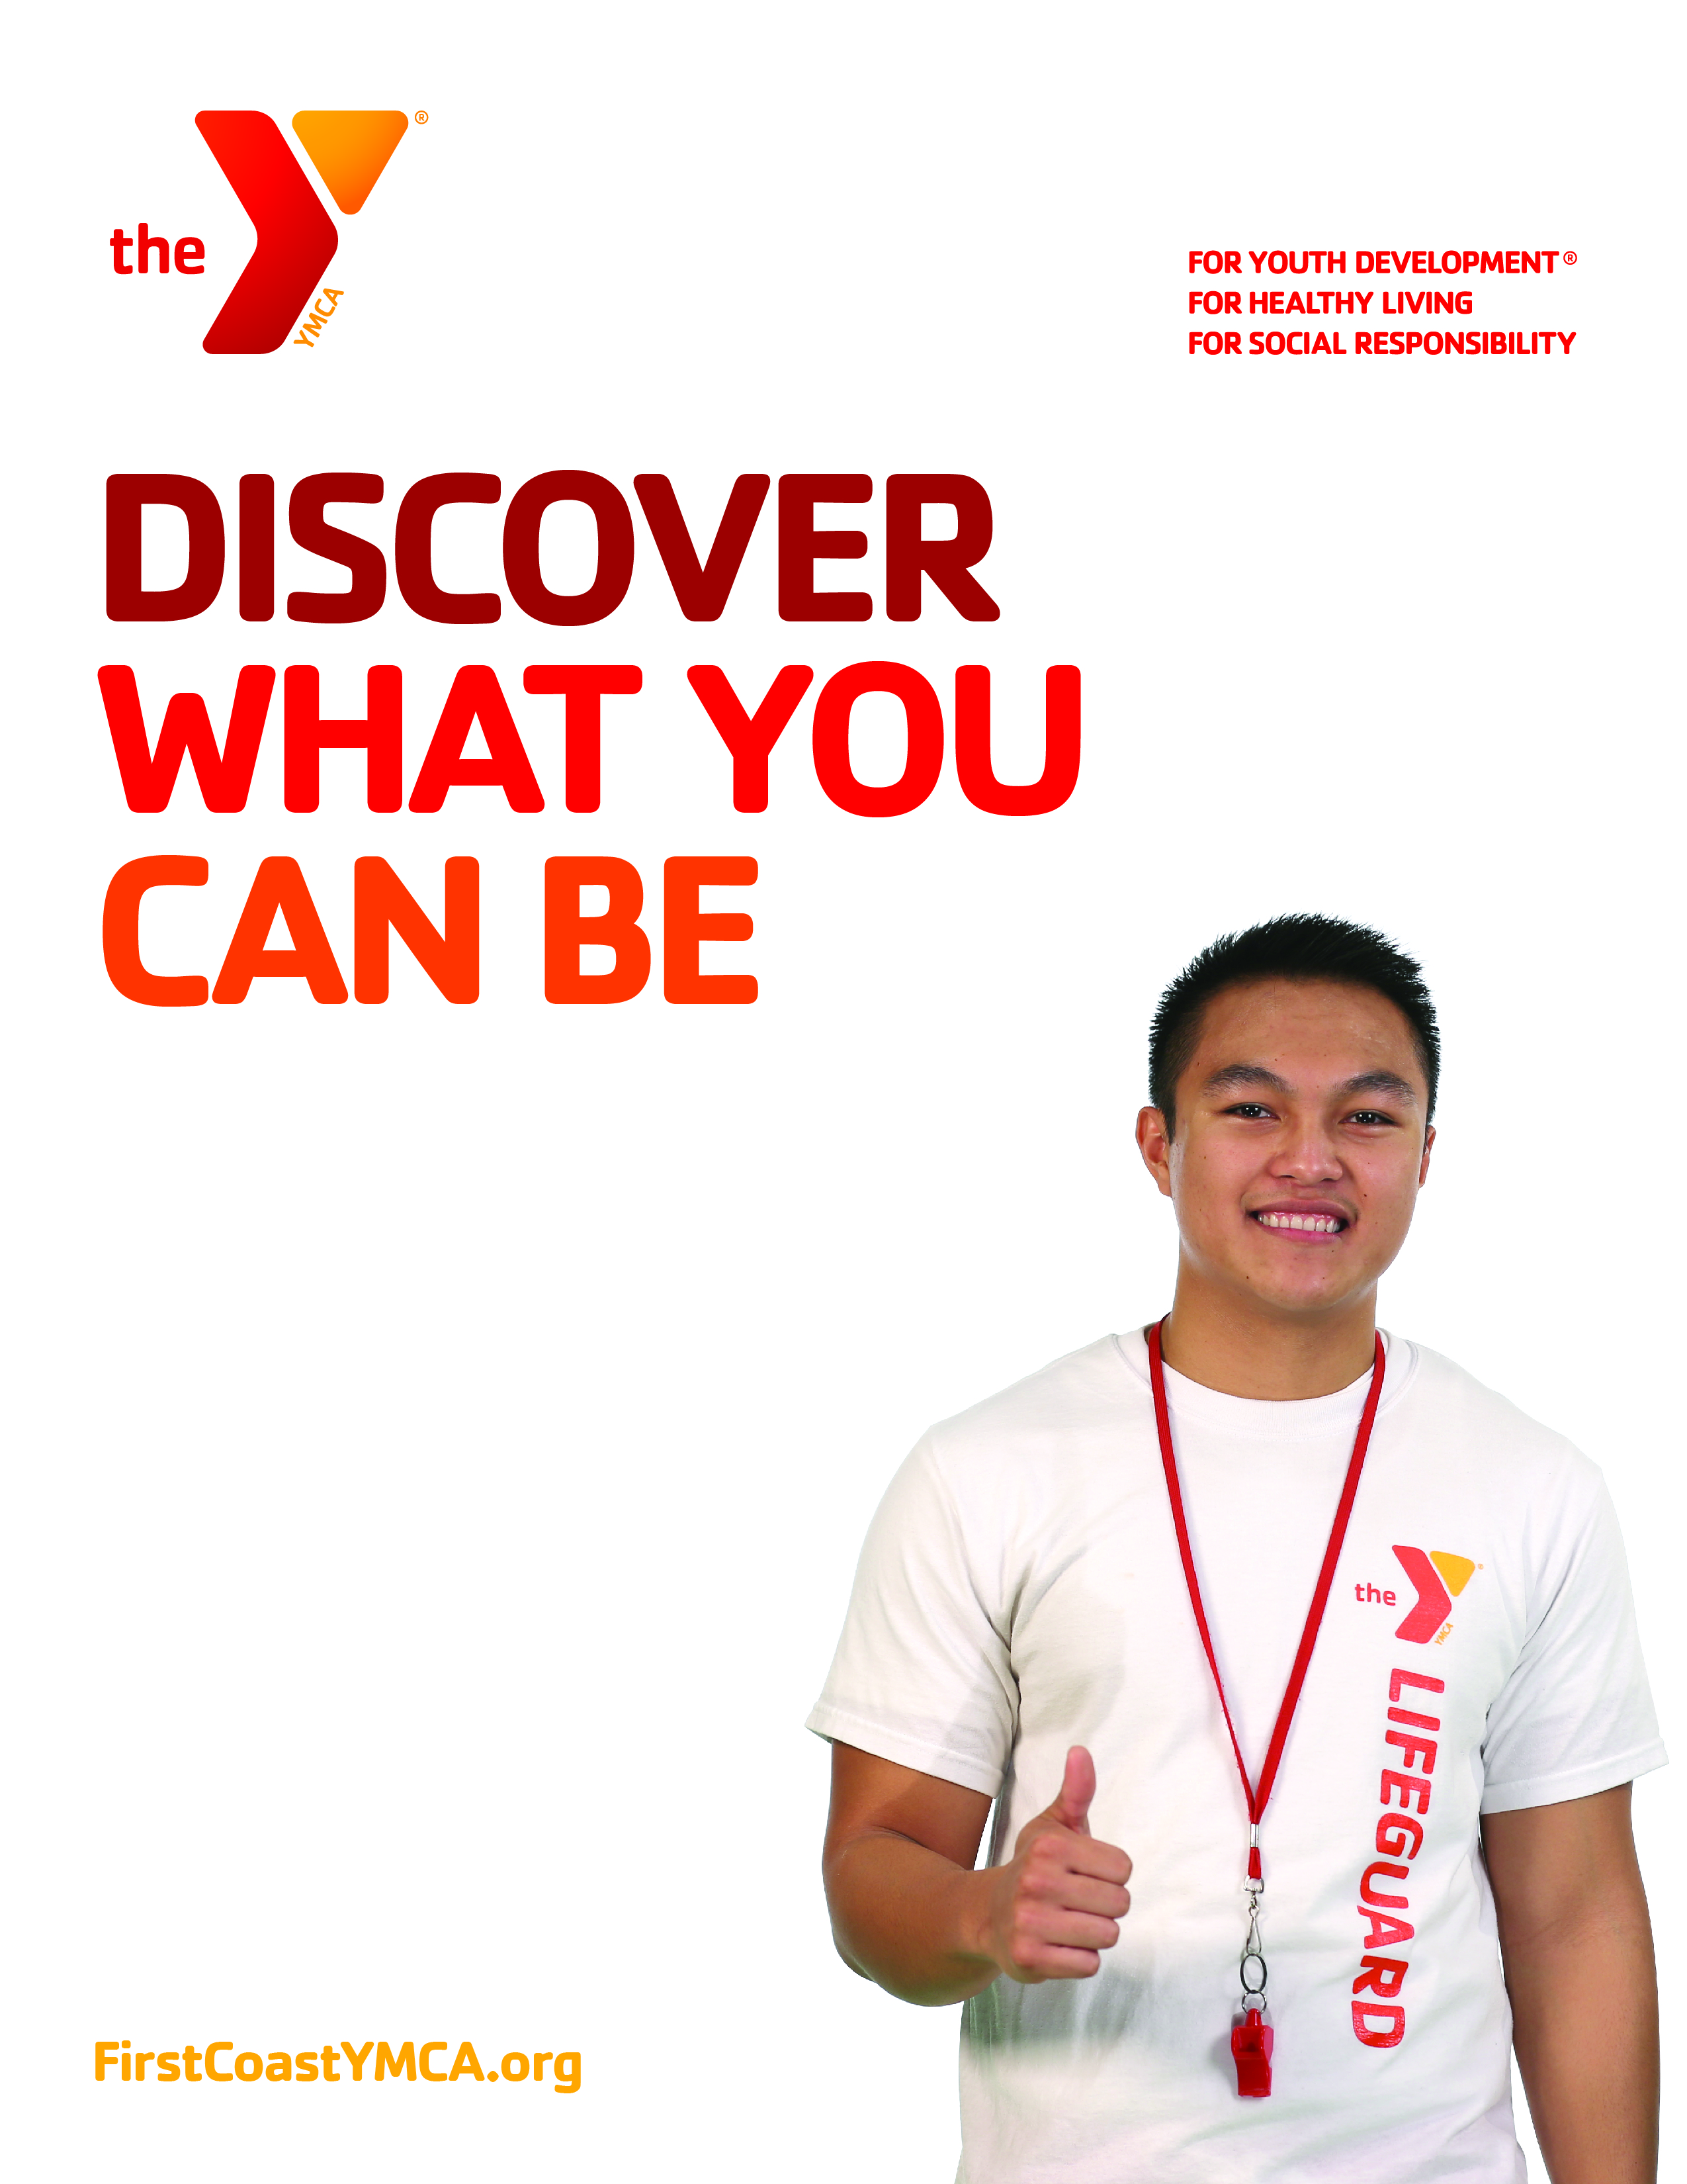

**Available Classes**

**Y Lifeguard –** 26-hr course, includes lifeguard certification, o2, CPR, AED and First aid

**Y Lifeguard Crossover –** Two-day course

**Y Swim Instructor –** Two-day course

**Y.S.I. Crossover –** One-day course

Apply today at **firstcoastymca.applicantpro.com/jobs**

Are you planning for a summer job or working during the school year? Join Y team! The following opportunities are now available:

* **Lifeguard**
* **Swim Coach**
* **Swim Instructor**
* **Aqua Fitness Instructors**

**Y Certification Classes Available**

YMCA of Florida’s First Coast