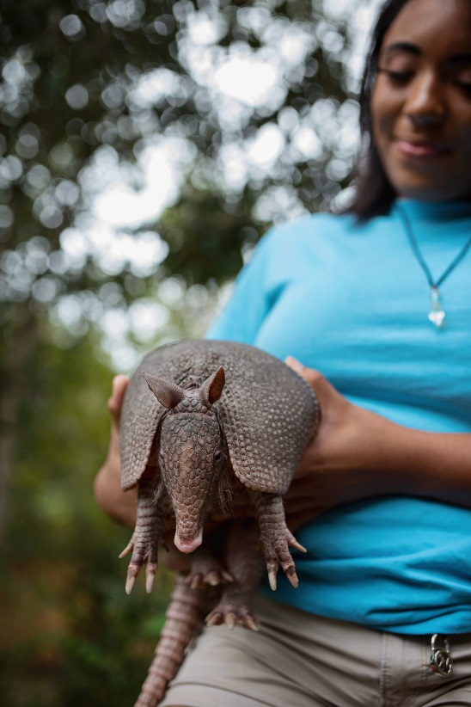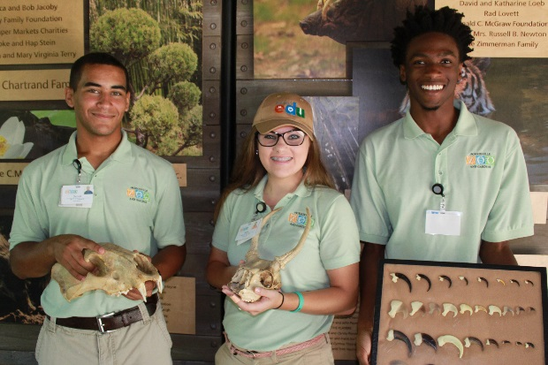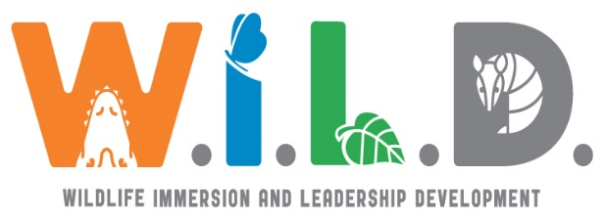

**Christopher Conner**

**W.I.L.D. Program Coordinator**

**(904) 757 - 4463 x484**

[**wildprogram@jacksonvillezoo.org**](mailto:wildprogram@jacksonvillezoo.org)

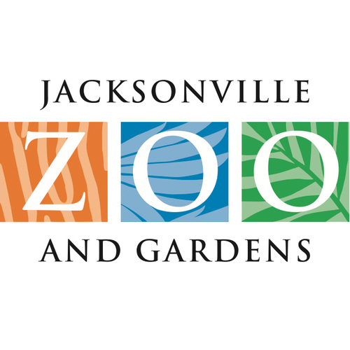

© Wurth Images, LLC

If you know a teen who would be an asset to this zoo program, please nominate them or have them contact us!

Join the team

Qualified teens will be selected through a competitive interview process to join the award-winning W.I.L.D. Program. This program seeks to offer a year-round enriching, paid position for teens to refine their sense of confidence, responsibility, leadership capabilities, and public speaking skills. Teens will play, learn, and work as a part of our Education staff to support our goals of culturally representing and inspiring everyone within our reach to deepen their

relationship with wildlife and

green spaces.

W.I.L.D. Stewards will give back to our community by creating and delivering free educational presentations using live animals at locations within the community.

The Jacksonville Zoo and Gardens is seeking nominations and applications for youth employment opportunities for teens from diverse cultural and economic backgrounds to work in our Education Department.

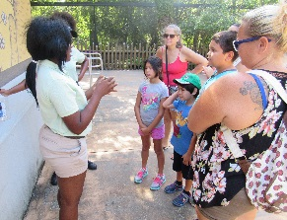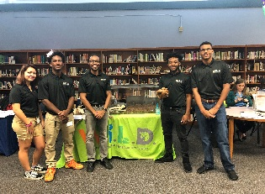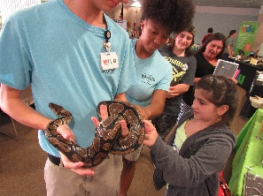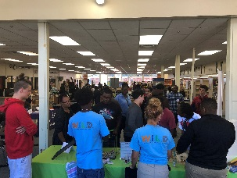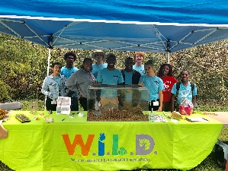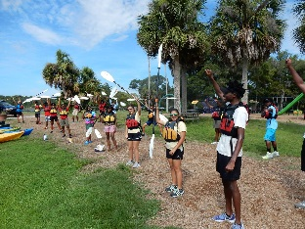

Be 14 - 18 years old by June 1, 2019

In High School (Can Be Rising Senior)

Have parental consent and letter of interest

Commit to working an average of 29 hours a week in the summer, and an average of 8 hours a week during the school year

Commit to Tues. through Sat. schedule

Must report to work on time

Have an email address and/or phone number used for work-related communications

Commit to teamwork, safety, education, and bettering the environment.

Strong work ethic; Willing to try your best

Physically able to work in a variety of conditions indoor or outdoor.

Ability to life 25 lbs., bend, stoop and stand

Willing and able to verbally express concepts to the team and public

Willing and able to work with a variety of animals, including insects, reptiles and amphibians

Demonstrate enthusiasm, professionalism, and willingness to learn, grow and develop

Leadership Development:

Establishing an inclusive culture

Mentoring by W.I.L.D. Ambassadors

Determining leadership strengths and most effective collaborative style

W.I.L.D. Steward Qualifications:

W.I.L.D. Steward Responsibilities

W.I.L.D. Stewards will commit to one year of employment in the Zoo’s Education Department. Stewards will deliver educational presentations with live animals, biological artifacts and interactive activities at locations throughout the community. This will take place through:

Public speaking:

Using interpretive skills to deliver effective messaging

Engaging in conservation conversations

Serve as Jacksonville Zoo and Gardens brand ambassador

Develop and present educational programs using live animals

Wild Immersion:

Understanding the role of zoos in conservation in wildlife and wild place

Handling and presenting a wide-variety of animals ranging from snakes to cockroaches

Nature adventures: Kayaking, fishing, hiking and camping

JZG On-Grounds Event

Summer 2018

Westside Career Fair

Oct. 2018

JZG Career Awareness Day

Nov. 2017

APR Career Fair

Oct. 2018



McCoy Creek Festival

Nov. 2018